**Database Relational**

**Part 1 - Schema Database**

**Part 2 - Data Definition Language**

1. 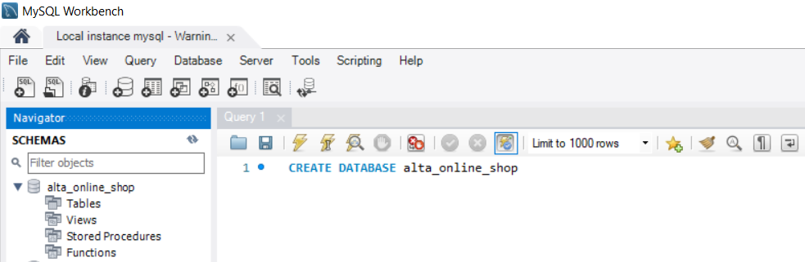Create database alta_online_shop
2. A. Create table user

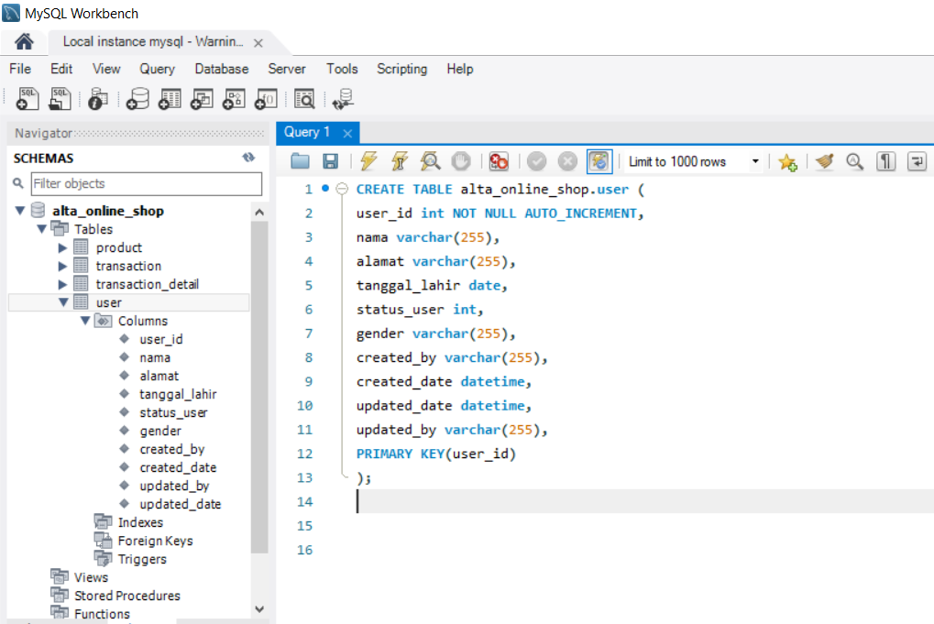

B. Create table product

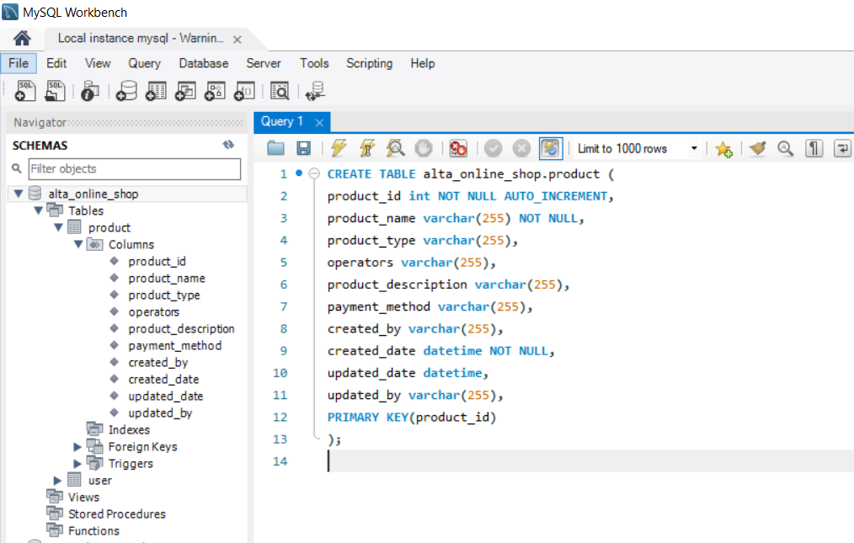

C. Create table transaction

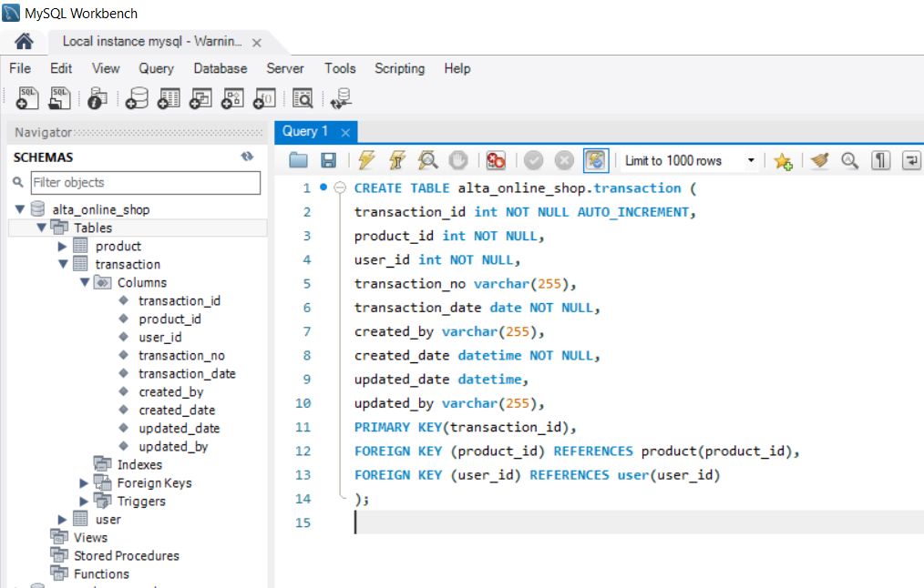

D. Create table transaction detail

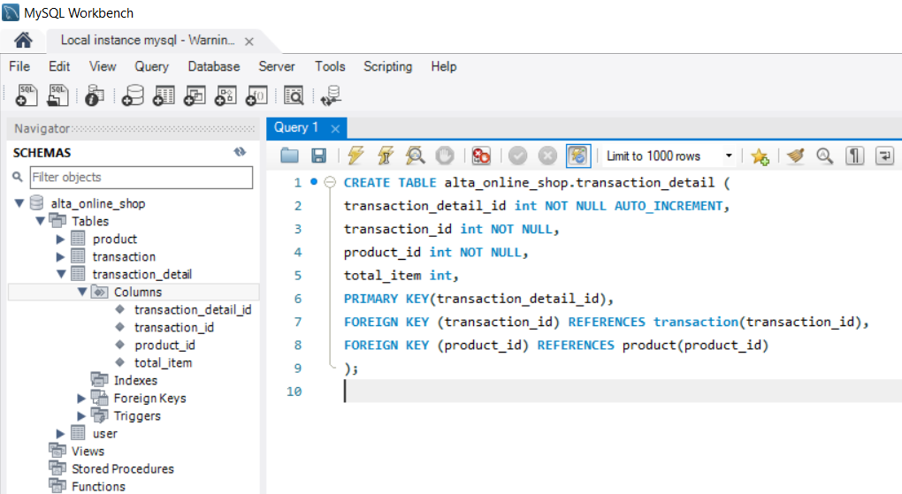

1. Create table kurir

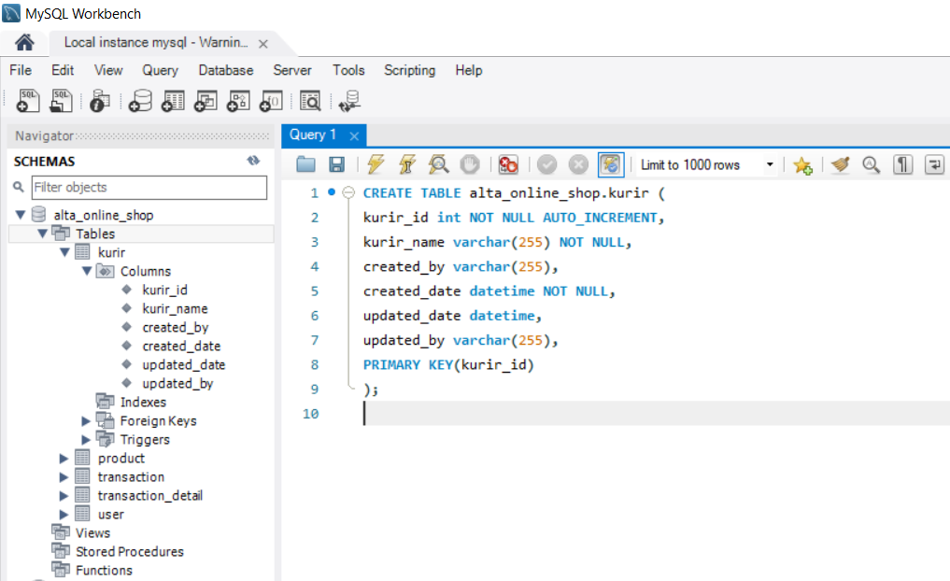

1. Alter table kurir kolom ongkos_dasar.

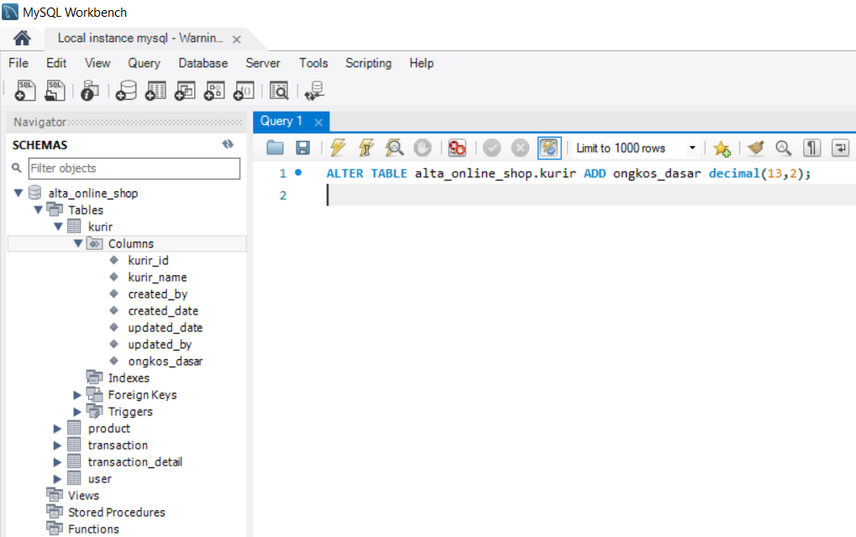

1. Rename table kurir menjadi table shipping.

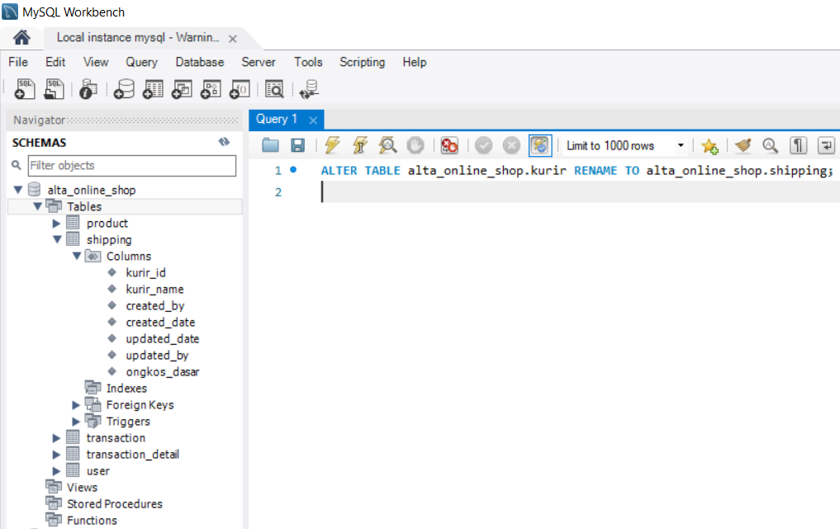

1. Drop table shipping.

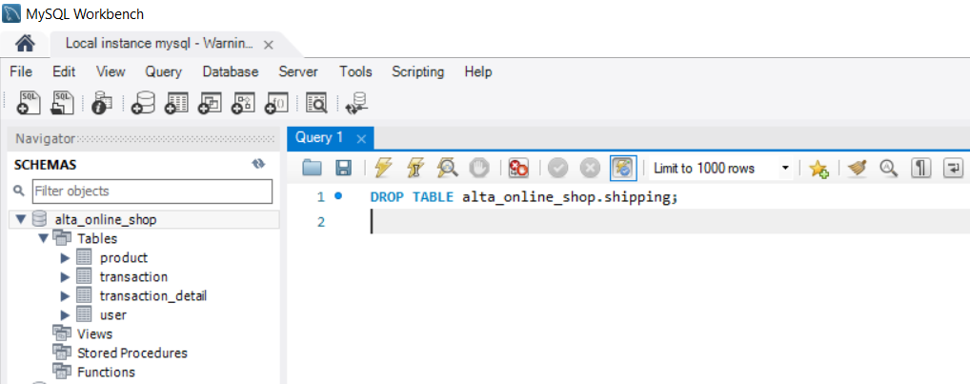

1. Create entity relation 1 to 1 , 1 to many, many to many.